|  |
| --- |
| **Neha Malhotra**  **R.L. Institute M: 9416974837**  **Class : XII**  **“SEXUAL REPRODUCTION IN FLOWERING PLANTS”** |

**Level – 1**

**(Based on Microsporogenesis & Megasporogenesis)**

1. Male gametophyte of angiosperms/monocot is :

|  |  |  |  |
| --- | --- | --- | --- |
| a) Microsporangium | b) Nucellus | c) Pollen grain | d) Stamen |

1. One of the most resistant biological material is :

|  |  |  |  |
| --- | --- | --- | --- |
| a) Lignin | b) Hemicellulose | c) Lignocellulose | d) Sporopollenin |

1. Exine of pollen is formed by activity of :

|  |  |  |  |
| --- | --- | --- | --- |
| a) Tapetum | b) Endothelium | c) Middle layers | d) Endothecium |

1. Male gametes are developed from generative cell by :

|  |  |  |  |
| --- | --- | --- | --- |
| a) Meiotic division | b) Mitotic division | c) Amitotic division | d) None of these |

1. Microsporogenesis occurs :

|  |  |
| --- | --- |
| a) on margins of leaves | b) Inside ovules |
| c) Inside anther | d) In essential floral organs |

1. Wall of pollen sac consists of :
2. Endothecium and tapetum
3. Tapetum and Middle layers
4. Endothecium , middle layers and tapetum
5. Epidermis , endothecium , middle layers and tapetum
6. Ubish bodies are produced by :

|  |  |  |  |
| --- | --- | --- | --- |
| a) Middle layers | b) Tapetal cells | c) Pollen mother cell | d) Endothecium |

1. In dicots, the most common pollen tetrad is :

|  |  |  |  |
| --- | --- | --- | --- |
| a) Isobilateral | b) Tetrahedral | c) Linear | d) T shaped/decussate |

1. In monocots, the most common pollen tetrad is :

|  |  |  |  |
| --- | --- | --- | --- |
| a) Isobilateral | b) Tetrahedral | c) Linear | d) T shaped/decussate |

1. The function of anther is to :

|  |  |
| --- | --- |
| a) produce Ubish granules | b) Produced pollen grains |
| c) Store and protect pollen grains | d) All of the above |

SEXUAL REPRODUCTION IN FLOWERING PLANTS Page No. 1

1. Intine of pollen grain is formed of :

|  |  |  |  |
| --- | --- | --- | --- |
| a) Callose | b) pectocellulose | c) cellulose | d) Sporopollenin |

1. Exine of pollen grain is formed of :

|  |  |  |  |
| --- | --- | --- | --- |
| a) Callose | b) pectocellulose | c) lignocellulose | d) Sporopollenin |

1. In ovule, meiosis occur in :

|  |  |  |  |
| --- | --- | --- | --- |
| a) Archesporial cell | b) Megasporocyte | c) Megaspore | d) parietal cell |

1. Pollen grain is liberated in :

|  |  |  |  |
| --- | --- | --- | --- |
| a) 1 – celled stage | b) 2 – celled stage | c) 3 – celled stage | d) 2 or 3 – celled stage |

1. Pollen tube is covered by :

|  |  |  |  |
| --- | --- | --- | --- |
| a) Pectocellulose | b) sporopollenin | c) cellulose | d) lignocellulose |

1. Which one of the following forms the pollen tube?

|  |  |  |  |
| --- | --- | --- | --- |
| a) Prothallial cell | b) vegetative cell | c) generative cell | d) stalk cell |

1. Number of nuclei present in the mature male gametophyte of majority of angiosperms is :

|  |  |  |  |
| --- | --- | --- | --- |
| a) 1 | b) 3 | c) 2 | d) many |

1. Pollinia are sacs having :

|  |  |
| --- | --- |
| a) anther lobes | b) pollen grains |
| c) Glands for secreting pollen kit | d) Air for making the pollen grains light |

1. Palynology is connected with the study of :

|  |  |  |  |
| --- | --- | --- | --- |
| a) pollen grains | b) Palms | c) flowers | d) Fruits |

1. Anther is typically :

|  |  |  |  |
| --- | --- | --- | --- |
| a) Tetrasporangiate | b) Bisporangiate | c) Trisporangiate | d) Monosporangiate |

1. Tapetum represent in the microsporangial wall occurs between :

|  |  |
| --- | --- |
| a) epidermis and endothecium | b) Endothecium and middle layers |
| c) Epidermis and middle layers | d) Middle layers and sporogenous tissue |

1. Tapetal cells show :

|  |  |
| --- | --- |
| a) Meiosis | b) Mitosis |
| c) Endomitosis | d) Endomitosis and Endopolyploidy |

1. Ubish bodies take part in development in :

|  |  |  |  |
| --- | --- | --- | --- |
| a) Pollen grains | b) syncytium | c) microgametophyte | d) microsporangium |

1. A pollinium consists of :
2. A bag od pollen grains formed in a microsporangium
3. A cluster of pollen grain belonging to a chamber of microsporangium
4. A group of 4 pollen grains derived from a single mother cell
5. Two pollen tetrad attached by small stalks.
6. Wall of mature pollen grain consists of :

|  |  |
| --- | --- |
| a) Ektexine and Endexine | b) Tapetum and endothecium |
| c) Exine and Tapetum | d) foot and baculate layer |

1. Germ pore/germinal furrow present on the surface of pollen grain represents :

|  |  |
| --- | --- |
| a) an area where exine is thin or absent | b) specialized thickening of exine |
| c) specialized thickening of intine | d) area where tapetum is absent |

SEXUAL REPRODUCTION IN FLOWERING PLANTS Page No. 2

1. The advantage of cross fertilization in plants is :

|  |  |
| --- | --- |
| a) increased genetic recombination | b) That meiosis can occur |
| c) greater efficiency of pollination | d) That no flowering is needed. |

1. Anther are :

|  |  |
| --- | --- |
| a) Externally tetralocular | b) internally tetralocular |
| c) Externally and internally tetralocular | d) Internally bilocular |

1. Monothecous anther are :

|  |  |  |  |
| --- | --- | --- | --- |
| a) Bisporangiate | b) Monosporangiate | c) Trisporangiate | d) Tetrasporangiate |

1. Endothecium layer of anther lobes is present :

|  |  |
| --- | --- |
| a) outside the epidermis | b) inner to epidermis |
| c) In the innermost layer | d) in the middle region |

1. How many pollen grains will be formed after meiotic division in 10 microspore mother cells?

|  |  |  |  |
| --- | --- | --- | --- |
| a) 10 | b) 20 | c) 40 | d) 80 |

1. Generative cell was destroyed by laser but a normal pollen tube was still formed because:
2. Vegetative cell is not damaged
3. Content of killed generative cell stimulate pollen growth
4. Laser beam stimulates growth of pollen tube
5. The region of emergence of pollen tube is not harmed.

|  |
| --- |
|  |

1. In the given figure of pollen grains, name the parts labelled as A, B , C, D and E.
2. A – Germ pore ; B – Generative cell ; C – intine ; D – Exine ; E – Vegetative cell
3. A – Germ pore ; B – Generative cell ; C – Exine ; D – Intine ; E – Vegetative cell
4. A – Intine ; B – Exine ; C – Germ pore ; D – Generative cell ; E – Vegetative cell
5. A – Exine ; B – Intine ; C – Vegetative cell ; D – Germ pore ; E – Generative cell
6. Consider the given figure and identify the labellings marked as A , B , C and D.

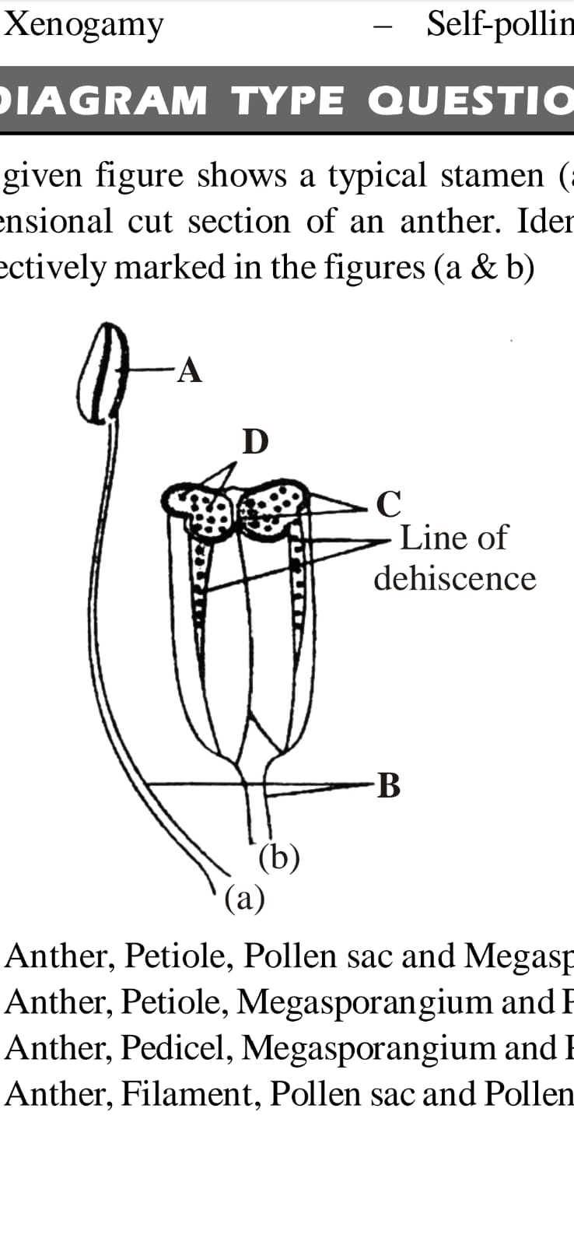

1. A – Anther ; B – Petiole ; C – Pollen sac ; D – Megaspore
2. A – Anther ; B – Petiole ; C – Megasporangium ; D – pollen grain
3. A – Anther ; B – Pedicle ; C – Megasporangium ; D – pollen grain
4. A – Anther ; B – Filament ; C – Pollen sac ; D – pollen grain

SEXUAL REPRODUCTION IN FLOWERING PLANTS Page No. 3

1. If there are 4 cells in anther, what will be the number of pollen grains?

|  |  |  |  |
| --- | --- | --- | --- |
| a) 8 | b) 4 | c) 16 | d) 12 |

1. The below diagram refers to T.S. of anther. Identify the parts marked as A to E.

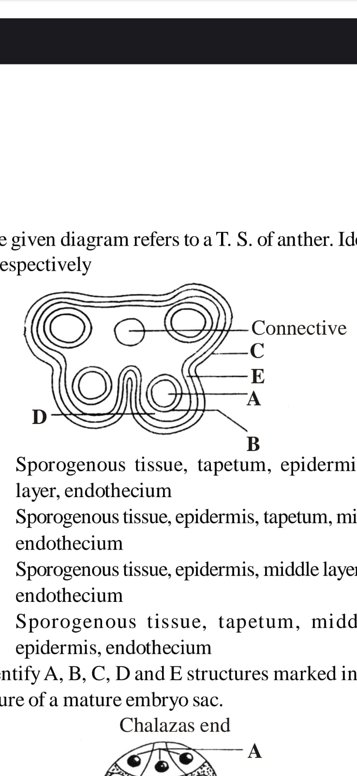

1. A – Sporogenous tissue ; B – Tapetum ; C – Epidermis ; D – Middle layer ; E – Endothecium
2. A – Sporogenous tissue ; B – Epidermis ; C – Tapetum ; D – Middle layer ; E – Endothecium
3. A – Sporogenous tissue ; B – Epidermis ; C – Middle layer ; D – Tapetum ; E – Endothecium
4. A – Sporogenous tissue ; B – Tapetum ; C – Middle layer ; D – Epidermis ; E – Endothecium
5. Match column I and column II

|  |  |  |
| --- | --- | --- |
| Column I | Column II | |
| A. Calyx | I. Carpel | |
| B. Corolla | II. Petal | |
| C. Androecium | III. Sepal | |
| D. Gynoecium | IV. Stamen | |
| a) A – II ; B – I ; C – IV ; D – III | | | b) A – I ; B – II ; C – III ; D – IV | |
| c) A – III ; B – II ; C – IV ; D – I | | | d) A – III ; B – IV ; C – I ; D – II | |

1. Match column I and column II

|  |  |  |
| --- | --- | --- |
| Column I | Column II | |
| A. Megasporogenesis | I. Monosporic development | |
| B. Microsporogenesis | II. Fatty substance | |
| C. Sporopollenin | III. Embryo sac formation | |
| D. Typical embryo sac | IV. Megaspore formation | |
| a) A – I ; B – II ; C – III ; D – IV | | | b) A – IV ; B – III ; C – II ; D – I | |
| c) A – IV ; B – I ; C – II ; D – III | | | d) A – III ; B – II ; C – I ; D – IV | |

1. Which of the following statement is correct about tapetum?
2. It is innermost layer of anther wall.
3. Cells of tapetum are large in size and has more than one diploid nucleus or polyploidy nucleus.
4. It contributes in the formation of Sporopollenin.
5. All of the above
6. Female gametophyte of angiosperms is represented by :

|  |  |  |  |
| --- | --- | --- | --- |
| a) ovule | b) megaspore mother cell | c) embryo sac | d) nucellus |

SEXUAL REPRODUCTION IN FLOWERING PLANTS Page No. 4

1. Which of the following pair has haploid structures?

|  |  |
| --- | --- |
| a) Nucellus and antipodal cells | b) Antipodal cells and egg cell |
| c) Antipodal cell and megaspore mother cell | d) Nucellus and primary endosperm cell |

1. Which of the following is odd one ?

|  |  |  |  |
| --- | --- | --- | --- |
| a) nucellus | b) embryo sac | c) micropyle | d) pollen grains |

1. An angiospermic plant with chromosome number 12 will chromosome number _______ in integuments and nucellus of :

|  |  |  |  |
| --- | --- | --- | --- |
| a) 4 | b) 6 | c) 12 | d) 24 |

1. What is the fate of the seven cells of the embryo sac?
2. All but one disintegrated upon fertilization
3. Two become fertilized , the other disintegrates
4. Two become fertilized ; the other fuse to form endosperm
5. All are involved in nuclear fusion events.
6. The stalk of ovule is :

|  |  |  |  |
| --- | --- | --- | --- |
| a) pedicel | b) funiculus | c) petiole | d) Rachiole |

1. What is the correct order of occurrence of structures in the formation of female gametophyte?
2. Megagametophyte $→$ Megasporocyte $→$ Megaspore
3. Megagametophyte $→$ Megaspore $→$ Megasporocyte
4. Megasporocyte $→$ Megaspore $→$ Megagametophyte
5. Megaspore $→$ Megasporocyte $→$ Megagametophyte
6. From Megasporocyte to egg cell, what processes are required?

|  |  |
| --- | --- |
| a) Meiosis followed by mitosis | b) Mitosis followed by meiosis |
| c) Several meiotic divisions only | d) Several mitotic divisions only |

1. Synergids are :

|  |  |  |  |
| --- | --- | --- | --- |
| a) Hexaploid | b) Haploid | c) Diploid | d) Triploid |

1. Technically correct names for floral whorl are :

|  |  |  |  |
| --- | --- | --- | --- |
| 1. Androecium | 1. Carpel | 1. Corolla | 1. Sepal |
| a) (i) and (ii) | b) (iii) and (iv) | c) (i) and (iii) | d) (i) and (iv) |

1. The arrangement of floral whorls on the thalamus from the outermost to the innermost is :

|  |  |
| --- | --- |
| a) Calyx , corolla , androecium , gynoecium | b) Calyx , corolla , gynoecium , androecium |
| c) Gynoecium , androecium , corolla , calyx | d) Androecium , gynoecium , corolla , calyx |

1. Identify those that are associated with the gynoecium :

|  |  |
| --- | --- |
| a) Stigma , ovule , embryo sac , placenta | b) Thalamus , pistil , style , ovule |
| c) Ovule , ovary , embryo sac , tapetum | d) Ovule , stamen , ovary , embryo sac |

1. The largest cell in an embryo sac is :

|  |  |  |  |
| --- | --- | --- | --- |
| a) egg | b) central cell | c) synergids | d) antipodal cell |

1. Ovules are attached to a parenchymatous cushion called :

|  |  |  |  |
| --- | --- | --- | --- |
| a) nucellus | b) obturator | c) conducting tissue | d) placenta |

SEXUAL REPRODUCTION IN FLOWERING PLANTS Page No. 5

1. Meiosis of megaspore mother cell generally produces :

|  |  |  |  |
| --- | --- | --- | --- |
| a) linear tetrad | b) tetrahedral tetrad | c) Decussate tetrad | d) Isobilateral tetrad |

1. Embryo sac is surrounded by :

|  |  |
| --- | --- |
| a) Membrane of megaspore | b) Transfer cell |
| c) Nucellar cell | d) membrane of egg |

1. Egg apparatus consists of :

|  |  |
| --- | --- |
| a) egg cell and antipodal | b) egg cell and central cell |
| c) egg cell and two synergids | d) egg cell and one synergids |

1. Embryo sac of flowering plants develops from :

|  |  |  |  |
| --- | --- | --- | --- |
| a) Zygote | b) megaspore | c) nucellus | d) embryo |

1. Which one is the female gamete in embryo sac?

|  |  |  |  |
| --- | --- | --- | --- |
| a) Synergids | b) antipodal cell | c) egg | d) central cell |

1. Vegetative nucleus occurs in :

|  |  |  |  |
| --- | --- | --- | --- |
| a) flowering plants | b) seed plants | c) vascular plants | d) embryophytes |

1. Polygonum type of embryo sac/typical female gametophyte of angiosperms is :

|  |  |
| --- | --- |
| a) 7 – celled , 7 – nucleated | b) 7 – celled , 8 – nucleated |
| c) 78 – celled , 7 – nucleated | d) 8 – celled , 8 – nucleated |

1. Embryo sac is Monosporic when it develops from :
2. One of the four megaspore , arising from a megaspore mother cell
3. Three megaspores of a megaspore tetrad
4. Two functional megaspore
5. The megaspore mother cell in which meiosis has occurred but cytokinesis does not take place
6. Ovule is curved and the embryo sac is horse-shoe shaped. Micropyle , chalaza and funicle occur near one another. The ovule is ;

|  |  |  |  |
| --- | --- | --- | --- |
| a) Campylotropous | b) Amphitropous | c) Orthotropous | d) Anatropous |

1. Ovule is inverted with body fused to funicle, Micropyle lying close to hilum and facing the placenta. It is :

|  |  |  |  |
| --- | --- | --- | --- |
| a) Hemitropous | b) Orthotropous | c) Anatropous | d) Campylotropous |

1. In a fertilized ovule n , 2n and 3n conditions occur respectively in :

|  |  |
| --- | --- |
| a) antipodal , egg and endosperm | b) egg , nucellus and endosperm |
| c) Endosperm , nucellus and egg | d) Antipodal , synergids and integuments |

1. In a flower , if the megaspore mother cell forms megaspores without undergoing meiosis and if one of the megaspores develops into an embryo sac, its nuclei would be :

|  |  |
| --- | --- |
| a) Haploid | b) Diploid |
| c) A few haploid and a few diploid | d) With varying ploidy |

1. Secondary nucleus in the middle of an embryo sac of angiosperms is :

|  |  |  |  |
| --- | --- | --- | --- |
| a) Diploid | b) Triploid | c) tetraploid | d) Haploid |

1. Flower is a highly modified and condensed reproductive shoot specially meant for :

|  |  |
| --- | --- |
| a) Vegetative reproduction | b) Sexual reproduction |
| c) Asexual reproduction | d) Parthenocarpic reproduction |

SEXUAL REPRODUCTION IN FLOWERING PLANTS Page No. 6

1. As a pollen tube grows into the female organ, the nucleus that enters the synergids first is celled the :

|  |  |  |  |
| --- | --- | --- | --- |
| a) sperm nucleus | b) generative nucleus | c) tube nucleus | d) pollen nucleus |

1. An angiospermic plant has to produce 88 viable ovules. How many meiotic divisions will be needed to produce equal number of female gametophytes by this plant?

|  |  |  |  |
| --- | --- | --- | --- |
| a) 88 | b) 22 | c) 44 | d) 132 |

1. Which of the following type of gynoecium is associated with wind pollination?

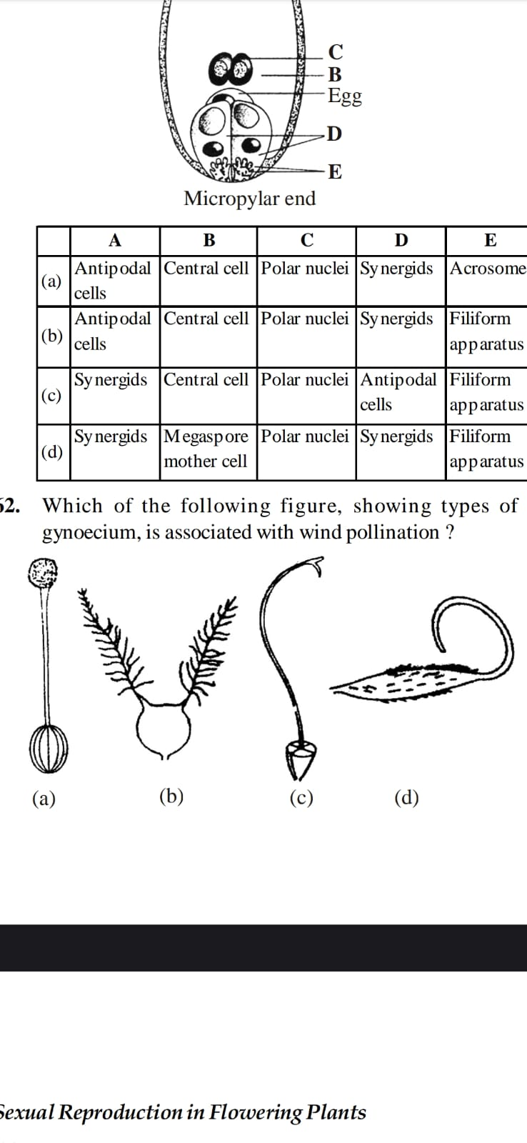

1. Identify the marked structures of a female gametophyte :

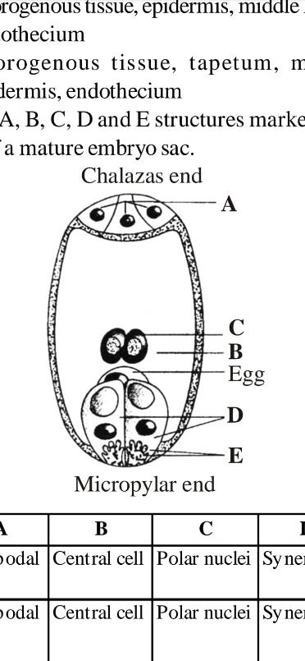

1. A – Antipodal cells ; B – Central cell ; C – Polar nuclei , D – Synergids , E – Acrosome
2. A – Antipodal cells ; B – Central cell ; C – Polar nuclei , D – Synergids , E – Filiform apparatus
3. A – Synergids ; B – Central cell ; C – Polar nuclei , D – Antipodal cells , E – Filiform apparatus
4. A – Synergids ; B – Megaspore mother cell ; C – Polar nuclei , D – Antipodal cells , E – Filiform apparatus
5. Consider the given figure of a pistil and identify labellings marked as A , B , C , D and E respectively :

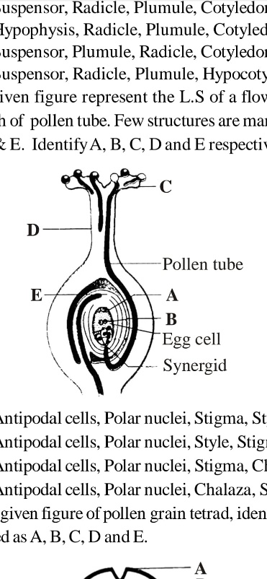

1. A – Antipodal cells ; B – Polar nuclei ; C – Stigma ; D – Style ; E – Chalaza
2. A – Antipodal cells ; B – Polar nuclei ; C – Style ; D – Stigma ; E – Chalaza
3. A – Antipodal cells ; B – Polar nuclei ; C – Stigma ; D – Chalaza ; E – Style
4. A – Antipodal cells ; B – Polar nuclei ; C – Chalaza ; D – Stigma ; E – Style

SEXUAL REPRODUCTION IN FLOWERING PLANTS Page No. 7

1. The given figure shows a diagrammatic view of a typical anatropous ovule, in which some parts are marked as A , B , C and E. Identify the correct labelling:

|  |
| --- |
|  |

1. A – Chalazal pole ; B – Micropyle ; C – Embryo sac ; D – Nucellus
2. A – Micropyle ; B – Chalazal pole ; C – Embryo sac ; D – Nucellus
3. A – Micropyle ; B – Chalazal pole ; C – Nucellus ; D – Embryo sac
4. A – Micropyle ; B – Nucellus ; C – Embryo sac ; D – Chalazal pole
5. Match column I and column II

|  |  |  |
| --- | --- | --- |
| Column I | Column II | |
| A. Funicle | I. Mass of cells with in ovule with more food | |
| B. Hilum | II. Chalazogamy | |
| C. Integument | III. One or 2 protective layers pf ovule | |
| D. Chalaza | IV. Region where body of ovule fuses with funicle | |
| E. Nucellus | V. Stalk of ovule | |
| a) A – I ; B – II ; C – III ; D – IV ; E – V | | | b) A – V ; B – IV ; C – III ; D – II ; E – I | |
| c) A – IV ; B – II ; C – I ; D – III ; E – V | | | d) A – I ; B – III ; C – V ; D – II ; E – IV | |

1. Which of the following has proved helpful in preserving pollen as a fossils?

|  |  |  |  |
| --- | --- | --- | --- |
| a) Pollen kit | b) Cellulosic intine | c) Sporopollenin | d) Oil content |

1. Pollen grains can be stored for several years in liquid nitrogen having a temperature of :

|  |  |  |  |
| --- | --- | --- | --- |
| a) – 120 $℃$ | b) – 80 $℃$ | c) – 160 $℃$ | d) – 196 $℃$ |

1. Functional megaspore in an angiosperm develops into :

|  |  |  |  |
| --- | --- | --- | --- |
| a) Endosperm | b) Embryo sac | c) Embryo | d) Ovule |

1. Which of the following statement is not true?
2. Tapetum helps in dehiscence of anther.
3. Exine of pollen is made up of sporopollenin.
4. Pollen grains of many species cause allergies.
5. Store pollen grain in liquid nitrogen can be used in crop breeding programmes.
6. Filiform apparatus is characteristics feature of :

|  |  |  |  |
| --- | --- | --- | --- |
| a) Nucellar embryo | b) Aleurone cell | c) Synergids | d) Generative cell |

1. Function of filiform apparatus is to :

|  |  |
| --- | --- |
| a) Recognize the suitable pollen at stigma | b) Stimulate division of generative cell |
| c) Produce nectar | d) Guide the entry of pollen tube |

SEXUAL REPRODUCTION IN FLOWERING PLANTS Page No. 8

1. Which of the following statement is correct?
2. Sporopollenin can withstand high temperature but not strong acids.
3. Sporopollenin can be degraded by enzymes.
4. Sporopollenin is made up of inorganic materials.
5. Sporopollenin can withstand high temperature as well as strong acids
6. Which of the following statement is correct?

|  |  |
| --- | --- |
| a) Sporogenous tissue is haploid. | b) Endothecium produces the microspore. |
| c) Tapetum nourishes the developing pollen | d) Hard outer covering of pollen is intine. |

1. What is the function of germ pore?

|  |  |
| --- | --- |
| a) Emergence of radicle | b) Absorption of water for seed germination |
| c) Initiation of pollen tube | d) Release of male gametes. |

1. An inorganic substance that can withstand environmental extremes and cannot be degraded by any enzyme is :

|  |  |  |  |
| --- | --- | --- | --- |
| a) Cuticle | b) sporopollenin | c) lignin | d) cellulose |

1. Given below the stages of embryo sac formation from megaspore mother cell. Identify A , B , C and D.
2. A – Meiosis I ; B – No division ; C – Mitosis ; D – Meiosis II.
3. A – Meiosis I ; B – Meiosis II ; C – No division ; D – Mitosis.
4. A – Mitosis ; B – No division ; C – Meiosis II ; D – Meiosis I.
5. A – No division ; B – Mitosis ; C – Meiosis I ; D – Meiosis II.

SEXUAL REPRODUCTION IN FLOWERING PLANTS Page No. 9

**Answers**

|  |  |  |  |  |  |  |  |
| --- | --- | --- | --- | --- | --- | --- | --- |
| 1. c | 1. d | 1. a | 1. b | 1. c | 1. d | 1. b | 1. b |
| 1. a | 1. b | 1. b | 1. d | 1. b | 1. d | 1. a | 1. b |
| 1. c | 1. b | 1. a | 1. a | 1. d | 1. d | 1. a | 1. a |
| 1. c | 1. a | 1. a | 1. b | 1. a | 1. b | 1. c | 1. a |
| 1. d | 1. d | 1. c | 1. a | 1. c | 1. b | 1. d | 1. c |
| 1. b | 1. d | 1. c | 1. b | 1. b | 1. c | 1. a | 1. b |
| 1. c | 1. a | 1. a | 1. b | 1. d | 1. a | 1. c | 1. c |
| 1. b | 1. c | 1. a | 1. b | 1. a | 1. b | 1. c | 1. b |
| 1. b | 1. a | 1. b | 1. c | 1. a | 1. b | 1. b | 1. a |
| 1. d | 1. b | 1. c | 1. d | 1. b | 1. a | 1. c | 1. d |
| 1. d | 1. c | 1. c | 1. b | 1. b |  |  |  |
|  |  |  |  |  |  |  |  |

SEXUAL REPRODUCTION IN FLOWERING PLANTS Page No. 10

|  |
| --- |
| **Neha Malhotra**  **R.L. Institute M: 9416974837**  **Class : XII**  **“SEXUAL REPRODUCTION IN FLOWERING PLANTS”** |

**Level – 2**

**(Based on Pollination & Double fertilization)**

1. Anemophily type of pollination is found in :

|  |  |  |  |
| --- | --- | --- | --- |
| a) Salvia | b) Bottle brush | c) Vallisneria | d) coconut |

1. Pollination occur in :

|  |  |
| --- | --- |
| a) Bryophytes and Angiosperms | b) Pteridophytes and Angiosperms |
| c) Angiosperms and Gymnosperms | d) Angiosperms and Fungi |

1. Cross pollination is preferred over self-pollination because

|  |  |
| --- | --- |
| a) it results in better offspring | b) the new varieties are formed |
| c) it is easy | d) Both (a) and (b) |

1. When pollen tube enters the ovule through the integuments, the phenomenon is called :

|  |  |  |  |
| --- | --- | --- | --- |
| a) Isogamy | b) Porogamy | c) Mesogamy | d) Chalazogamy |

1. After pollination, which of the following events is crucial for fertilization?

|  |  |
| --- | --- |
| a) Sperm swim to the egg and the polar nuclei | b) Petals close around the reproductive parts |
| c) Meiosis occurred within the pollen grain | d) A pollen tube grow from stigma to ovule. |

1. For self pollination, flower must be :

|  |  |  |  |
| --- | --- | --- | --- |
| a) Unisexual | b) Bisexual | c) Monosexual | d) Asexual |

1. The phenomenon of floral parts acting as a barrier to self pollination is :

|  |  |  |  |
| --- | --- | --- | --- |
| a) Dicling | b) Protandry | c) Heterostyly | d) Herkogamy |

1. The phenomenon of two flowers, one having long stamens and short styles, and other having short stamens and long styles, called :

|  |  |  |  |
| --- | --- | --- | --- |
| a) Dicling | b) Heterostyly | c) Allogamy | d) Herkogamy |

1. Maturation of anthers and stigma at the same time is called :

|  |  |  |  |
| --- | --- | --- | --- |
| a) Allogamy | b) Xenogamy | c) Homogamy | d) Dichogamy |

1. What is the other name of double fertilization?

|  |  |  |  |
| --- | --- | --- | --- |
| a) Central fertilization | b) Somatogamy | c) Triple fusion | d) None of these |

1. Pollination is :

|  |  |
| --- | --- |
| a) shedding of pollen from anthers | b) similar to fertilization of animals |
| c) transfer of pollen from anther to stigma | d) transfer of pollen from anther to ovules |

SEXUAL REPRODUCTION IN FLOWERING PLANTS Page No. 11

1. Passage of pollen grains from anther of one flower to stigma of other flower is called :

|  |  |  |  |
| --- | --- | --- | --- |
| a) Allogamy | b) Chasmogamy | c) Cleistogamy | d) Autogamy |

1. Xenogamy is :

|  |  |  |  |
| --- | --- | --- | --- |
| a) Autogamy | b) cross pollination | c) self pollination | d) Cleistogamy |

1. A mechanism to prevent cross pollination is :

|  |  |  |  |
| --- | --- | --- | --- |
| a) Protogyny | b) Protandry | c) Heterostyly | d) Cleistogamy |

1. Repeated self pollination over the generations produces:

|  |  |
| --- | --- |
| a) New varieties | b) Elimination of weak traits |
| c) Better progeny | d) Weak progeny |

1. Cleistogamous flowers are :

|  |  |  |  |
| --- | --- | --- | --- |
| a) wind pollinated | b) self pollinated | c) cross pollinated | d) Insect pollinated |

1. A characteristics of wind pollinated flowers are :

|  |  |
| --- | --- |
| a) Feathery exserted stigma | b) Feathery inserted stigma |
| c) Narrow exserted stigma | d) Narrow inserted stigma |

1. Wind-pollinated flowers have :

|  |  |
| --- | --- |
| a) small petals and sticky pollen | b) no petals and light pollen |
| c) coloured and large petals with large pollen | d) small petals and heavy pollen. |

1. Pollination carried out through water is called :

|  |  |  |  |
| --- | --- | --- | --- |
| a) Anemochory | b) Hydrophily | c) Hydrochory | d) Anemophily |

1. Pollination by water occurs in :

|  |  |  |  |
| --- | --- | --- | --- |
| a) Ceratophyllum | b) Zostera | c) Hydrilla | d) all of these |

1. Pollination occurred by snails is called :

|  |  |  |  |
| --- | --- | --- | --- |
| a) Myrmecophily | b) Malacophily | c) Ornithophily | d) Entomophily |

1. In angiosperms, syngamy refers to :
2. Fusion of male gamete with secondary nucleus.
3. Fusion of a male gamete with oosphere (egg).
4. Fusion of one male gamete with egg and other with secondary nucleus.
5. Fusion of one of the sperm with synergids.
6. Allogamy is favoured by ;

|  |  |  |  |
| --- | --- | --- | --- |
| a) Homogamy | b) Cleistogamy | c) Monocliny | d) Dicling |

1. Pollination performed by bats is called :

|  |  |  |  |
| --- | --- | --- | --- |
| a) Myrmecophily | b) Entomophily | c) Ornithophily | d) Chiropterophily |

1. The condition of maturation of stigma before anthers of same flower is :

|  |  |  |  |
| --- | --- | --- | --- |
| a) Protandry | b) Herkogamy | c) Protogyny | d) Prepotency |

1. The condition of maturation of anther earlier than the stigma of same flower is :

|  |  |  |  |
| --- | --- | --- | --- |
| a) Dicling | b) Protandry | c) Herkogamy | d) Heterostyly |

1. Double fertilization and triple fertilization was discovered by :

|  |  |  |  |
| --- | --- | --- | --- |
| a) Hofmeister | b) Nawaschin & Guignard | c) Leeuwenhoek | d) Strasburger |

SEXUAL REPRODUCTION IN FLOWERING PLANTS Page No. 12

1. Entomophily is pollination by :

|  |  |  |  |
| --- | --- | --- | --- |
| a) Insects | b) Bats | c) Birds | d) ants |

1. Mesogamy is :
2. Fusion of male and female gametes.
3. Fusion of physiologically similar and morphologically different gametes.
4. Entry of pollen tube with integuments.
5. None of the above.
6. The plant that flowers once in its life time, is called :

|  |  |  |  |
| --- | --- | --- | --- |
| a) Cleistogamous | b) Polycarpic | c) Cleistocarpic | d) Monocarpic |

1. In Insect-pollinated pollen grains, tapetum helps in the development of :

|  |  |  |  |
| --- | --- | --- | --- |
| a) Sporopollenin | b) Cellulose | c) Pectin | d) Pollen kit |

1. 3-celled stage of the mature male gametophyte is reached :

|  |  |  |  |
| --- | --- | --- | --- |
| a) Before pollination | b) After pollination | c) During fertilization | d) After fertilization |

1. In an artificial hybridized plants, the flowers are first emasculated. which of the following organ is removed in this process?

|  |  |  |  |
| --- | --- | --- | --- |
| a) Ovary | b) Ovules | c) Stigma | d) Stamen |

1. Function of synergids is :
2. Attract pollen tube and bear its shock.
3. Fuse with extra male gametes and form endosperm.
4. Produce additional embryo.
5. Protect egg from pathogens.
6. In a somatic cell, there are 16 chromosomes. What will be the number of chromosomes in the pollen mother cell of the plant?

|  |  |  |  |
| --- | --- | --- | --- |
| a) 16 | b) 8 | c) 24 | d) 32 |

1. Function of funicle includes :
2. Provides support to the body.
3. Supplying nutrients to the body from the placenta.
4. Both (a) and (b)
5. None of these
6. If the haploid number in a flowering plant is 14. What shall be the number of chromosomes in integuments, antipodal cells, embryo , endosperm, and nucellus respectively?

|  |  |  |  |
| --- | --- | --- | --- |
| a) 14 , 28 , 7 , 42 , 21 | b) 7 , 14 , 42 , 28 , 14 | c) 28 , 14 , 28 , 42 , 28 | d) 42 , 28 , 14 , 28 , 14 |

1. Double fertilization leading to initiation of endosperm in angiosperm requires :
2. Fusion of one polar nuclei and the second male gamete only.
3. Fusion of two polar nuclei and the second male gamete.
4. Fusion of four or more polar nuclei and the second male gamete only.
5. None of these.

SEXUAL REPRODUCTION IN FLOWERING PLANTS Page No. 13

1. In angiosperms, pollen tubes liberate their male gametes into the :

|  |  |  |  |
| --- | --- | --- | --- |
| a) Central cell | b) Antipodal cell | c) Egg cell | d) Synergids |

1. Which of the following statements is/are correct about self-incompatibility?
2. It is a device to prevent inbreeding.
3. It is governed by series of multiple alleles.
4. It ensures cross-fertilization.
5. It is governed by pollen-pistil interactions.
6. It prevents self pollen from fertilizing the ovules by inhibiting pollen germination of pollen tube growth in the pistil.

|  |  |  |  |
| --- | --- | --- | --- |
| a) All are correct | b) all are incorrect | c) (i) , (ii) , (iii) | d) (iv) , (v) |

1. Which of the following statements is correct with reference to cross pollination in angiosperms?
2. It required production of large number of pollen grains.
3. It can fail to occur due to distance barrier.
4. It occurs only in unisexual flowers.
5. It most often results in high yield of plants.
6. Which of the following statements are correct with reference to self pollination in angiosperms?
7. Self-pollination is the most economic method as wastage of pollen grain is minimum.
8. Genetic stability can be maintained in the progeny through self-pollination.
9. Undesirable characters can be eliminated through self-pollination.
10. Continued self-pollination may result in weaker progeny.
11. Self-pollination favours evolution.

|  |  |  |  |
| --- | --- | --- | --- |
| a) (i) , (ii) , (iv) | b) (iii) , (v) | c) (i) , (iii) , (v) | d) All are correct |

1. Find the odd statements regarding to cross-pollination.
2. Cross-pollination involves genetic recombination and bring variation.
3. The offspring produced through cross-pollination shows hybrid vigour.
4. Purity maintained in the offspring produced through cross-pollination.
5. It is not an economical method.
6. What is the fate of male gamete discharged in the synergid?
7. One fuse with the egg, other degenerates in the synergids.
8. All fuse with the egg.
9. One fuse with egg and other fuse with synergid nucleus.
10. One fuse with egg and other fuse with central cell nuclei.
11. A dioecious flowering plant prevents both :

|  |  |
| --- | --- |
| a) Autogamy and Geitonogamy | b) Geitonogamy and Xenogamy |
| c) Cleistogamy and Xenogamy | d) Autogamy and Xenogamy |

1. Flowers which have single ovule in the ovary and are packed into inflorescence are usually pollinated by :

|  |  |  |  |
| --- | --- | --- | --- |
| a) Bee | b) Wind | c) Bat | d) Water |

1. Attractants and rewards are required for :

|  |  |  |  |
| --- | --- | --- | --- |
| a) Entomophily | b) Hydrophily | c) Cleistogamy | d) Anemophily |

SEXUAL REPRODUCTION IN FLOWERING PLANTS Page No. 14

1. Which of the following may require pollinators but genetically similar to autogamy?

|  |  |  |  |
| --- | --- | --- | --- |
| a) Xenogamy | b) Apogamy | c) Cleistogamy | d) Geitonogamy |

1. Both autogamy an geitonogamy is prevented in :

|  |  |  |  |
| --- | --- | --- | --- |
| a) Papaya | b) cucumber | c) castor | d) maize |

1. Wind pollination is common in :

|  |  |  |  |
| --- | --- | --- | --- |
| a) legumes | b) lilies | c) grasses | d) orchids |

1. Chasmogamous flower is refers to the condition when :

|  |  |
| --- | --- |
| a) Flowers remains closed | b) Flowers are absent |
| c) Flowers are open | d) Flowers are gamopetalous |

1. Male gametophyte of angiosperms/monocot is :

|  |  |  |  |
| --- | --- | --- | --- |
| a) | b) | c) | d) |

1. Microsporogenesis occurs :

|  |  |
| --- | --- |
| a) | b) |
| c) | d) |

**Answers**

|  |  |  |  |  |  |  |  |
| --- | --- | --- | --- | --- | --- | --- | --- |
|  |  |  |  |  |  |  |  |
|  |  |  |  |  |  |  |  |
|  |  |  |  |  |  |  |  |
|  |  |  |  |  |  |  |  |
|  |  |  |  |  |  |  |  |
|  |  |  |  |  |  |  |  |
|  |  |  |  |  |  |  |  |

|  |
| --- |
| **Neha Malhotra**  **R.L. Institute M: 9416974837**  **Class : XII**  **“SEXUAL REPRODUCTION IN FLOWERING PLANTS”** |

**Level – 3**

**(Based on Post Fertilization Events)**

1. Anemophily type of pollination is found in :

|  |  |  |  |
| --- | --- | --- | --- |
| a) | b) | c) | d) |

1. Pollination occur in :

|  |  |
| --- | --- |
| a) | b) |
| c) | d) |